 | Curriculum: ACCPi7.1  Subject: HDJ-DWMX  Duration: 120 minutes  Total Marks: 25  Exam Date: 31-Dec-08

MODULE TEST PRACTICAL

Note : Students must save his/her programs as following rules:
- Put all files for Question 1 into QUESTION1 Folder.
- Put all files for Question 2 into QUESTION2 Folder.

If this rule is violated, the examination will be ignored.

Question 1 [8.0]
Create a form as shown in Figure 1 using HTML and Dreamweaver : [8.0]
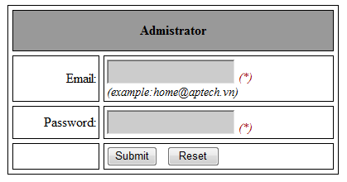
Figure 1
- When user Click on Reset Button, all field must be cleared.
- When user Click on Submit Button, following validations will be performed:
- Email can not be empty.
- Email must be format.(example: admin@aptech.vn).
- Password can not be empty.
- Password must include full character as: a-z; A-Z;1-9, ~;@;#;$;?; (each character appears at least 1 times)
- If value are invalid, display an error message corresponding.(use alert function)
- If value are valid and email equal to ‘admin@aptech.vn’ , password equal to ‘aA1~@#$?’ show the productadnew.html page. (as shown in Figure 2).
Question 2 [17]
Create a form as shown in Figure 2 using HTML and Dreamweaver : [5]
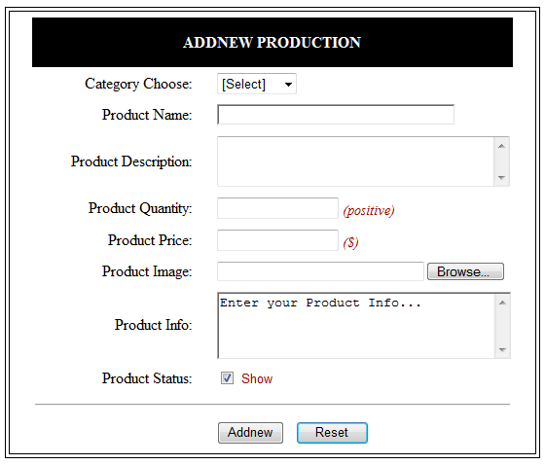
Figure 2
- When user Click on Reset Button, all field must be cleared, field Product Info is value “Enter your Product Info…..”. [0.5]
- Change the color of ‘ADDNEW PRODUCTION’ when the mouse is moved over it to RED, and back to original color when the mouse pointer moves out of it. [0.5]
- Category choose drop down list has the follwing option: [1.0]
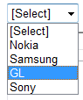
User must select 1 category
- When each field receives focus (Product Name, Product Description, Product Quantity, Product Price, Product Info), change its background color to Black and fontcolor to white, when user leaves change the backgound color back to normal. (Example) [1.0]
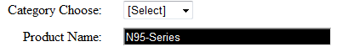
- When user Click on Product Status check: [1.0]
- If Product Status is true, display ‘show’ as Figure 2 else display ‘hidden’.
Example: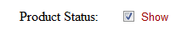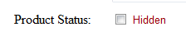
- When user Click on Addnew Button, following validations will be performed :
(NOTE: If value are invalid, display an error message corresponding)
- Category choose must select. [1.0]
- Product Name only contain characters, digits, minus sign , space and not empty. (a-z,A-Z, 0-9, ,-,_). [1.0]
- Product Quantity must be positive and not empty. [1.5]
- Product Quantity is value ranges from 1-100. [1.0]
- Product Price must be the number and greater than 0 and not empty. [1.0]
- Product Description not empty and not exceed 200 characters. [1.0]
- If values in all field are valid, an Message Box will be display with these information. [1.5]
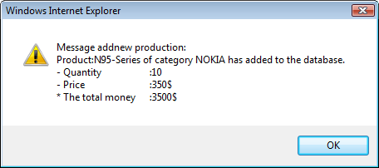
where,
  - ‘N95-series’ from the product name.
  - ‘NOKIA’ select category.
  - ‘10’ from the Product Quantity.
  - ‘350’ from the Product Price.
  - ‘3500$’ calculated from [Product Name] * [Product Price].

